language Policy

Ralph J. Bunche Middle School

Atlanta, Georgia

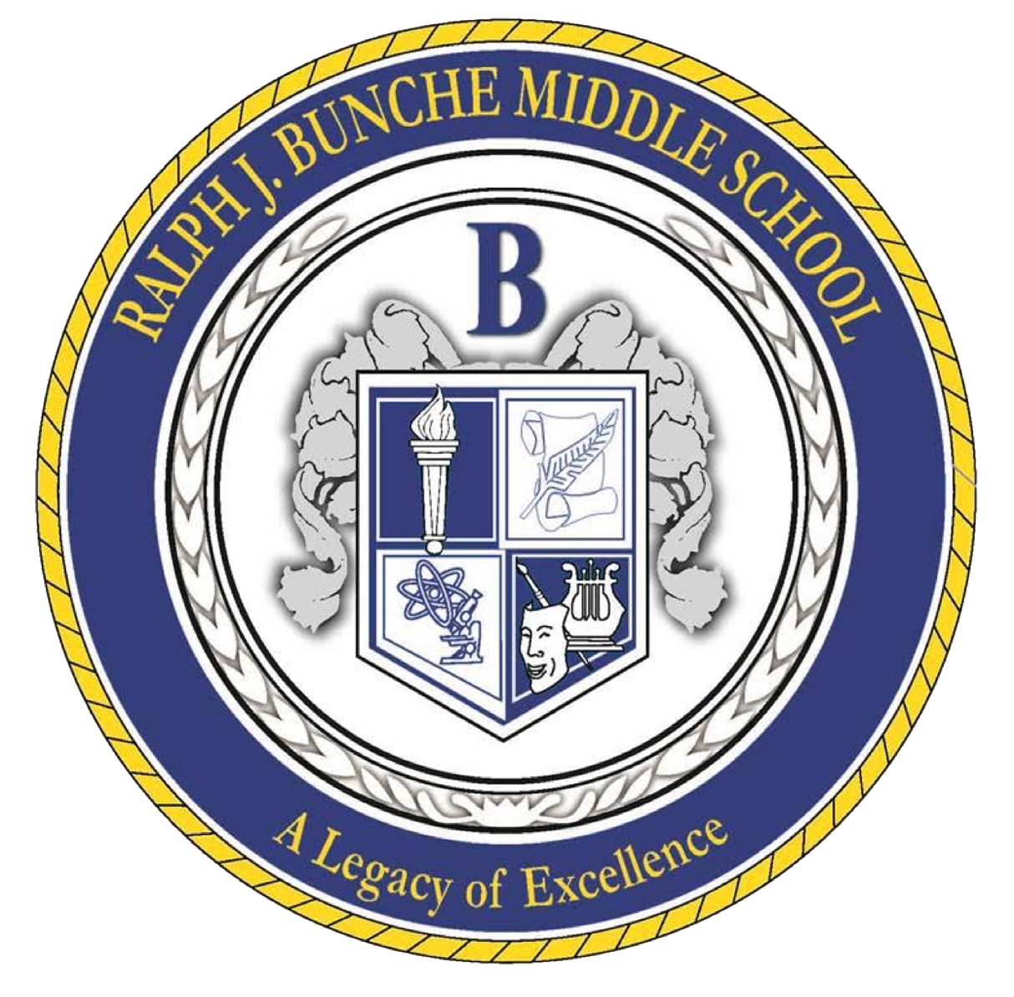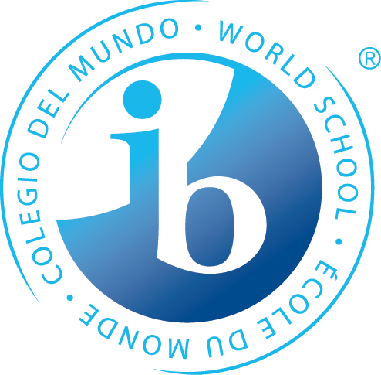

**The Bunche Mission Statement**

Through rigorous learning experiences and a challenging international education program, Ralph J Bunche will develop 21st-century lifelong learners who are competent, caring, and contributing members of a global society prepared for high school and beyond.

**Purpose**

At Ralph J. Bunche Middle School (BMS), we believe that language development is the responsibility of all stakeholders, including students, teachers, staff, administrators, families, and the community. Language learning includes reading, writing, speaking, and listening. BMS firmly supports the International Baccalaureate and adheres to the requirement that all MYP students participate in a second language.

Our language of instruction at BMS is English. BMS currently offers French and Spanish as language acquisition courses but plans to offer other world language courses. BMS aims to provide a rigorous educational model while fully supporting the cultural diversity and population we serve. We have identified the importance of language development and its correlation to holistic learning and the growth of the whole student.

The language policy committee comprises teachers, leadership staff, and administrators from BMS’ International Baccalaureate Middle Years Programme (IB MYP). Together, they developed this document to outline the critical components of our Language Policy. The committee members have drawn from their diverse backgrounds and expertise to create an effective policy that reflects the latest research and best practices in language learning.

**Philosophy**

Ralph J. Bunche Middle School recognizes that language is central to all learning. Language study develops international understanding, reinforces cultural identity, enhances personal growth, and promotes effective communication. Through a shared responsibility of all teachers, parents, administrators, and students, we foster the development of the language of instruction, world languages, and the native tongue to develop students as proficient communicators in a global society.

**Overview of Languages**

* English is the language of instruction.
* English as a subject is taught through:
* Language and Literature in the MYP
* ELL as a support program
* World languages offered:
* French
* Spanish
* In the home environment, students speak various languages, including English, Spanish, and French.
* Students whose native tongue is not English may use native language resources and language skills to help facilitate their learning within the classroom.
* BMS offers various foreign language clubs to support students with different mother tongues.

**Definitions**

Mother-Tongue- “The language(s) learned first; the language(s) identified as a “native speaker; the language known best, the language used most.” The term is best described as the language the student predominantly uses outside the education setting. Mother Tongue is typically the language frequently spoken by all family members at home.

* Second Language/Language Acquisition/Language B- Describes the language learned subsequently to the first language to access the language with competence outside of the classroom setting.
* Language Acquisition: Language Acquisition aims to communicate in both an educational and real-world setting.
* English Language Learners (ELL) - This refers to those MYP students whose first language is not English. At BMS, we provide a differentiated approach to learning and assessment. Accommodations may be applied to all forms of assessments, including, but not limited to, extended time for oral and written response, reducing the number of items on a test or the number of answer choices, oral reading of the test, small group testing, use of a calculator or formula chart, use of a dictionary or assistive technology, and paper-based tests. Accommodations are included within each student’s Individual Education Plan (IEP) or outlined on the English Language Learners (ELL) strategies matrix.

**English Language Learners**

Students whose primary language is other than English will be provided a range of services from teachers, facilitators, and administrators at BMS with support from the Atlanta Public Schools District. All English Language Learner (ELL) students shall be appropriately identified, assessed, and placed in the appropriate ELL programs. The programs offered at each school shall be based on research and provide age-appropriate English proficiency levels. In addition, the program shall be aligned with the IB MYP curriculum and taught using the content strategies and thinking processes that students encounter as they pursue an education in our schools. It will also reflect ELL students' many cultural and linguistic backgrounds in Atlanta Public Schools.

**Language Resources**

Bunche Middle School respects the development of a student's preferred home language. To help students inquire about their family’s preferred home language, BMS offers the following: text in the library in multiple languages, access to the Fulton County library ebook system with texts in various languages, Hoopla, the encouragement of speaking in the preferred language in social and collaborative work settings.

In addition, BMS celebrates language differences by recognizing language and literacy awareness observances, such as American Sign Language Day, National Francophone Day, UN, Spanish Day, and World Literacy Day with community involvement.

The school shares with parents how they can support their scholars in developing their children's language identities by taking advantage of the books available at the school l; library and the local library in the native language and how to build their skills in the English language. The parent liaison also conducts parent universities to help the parents and share resources on how best to support their children's journey in their new environment.

**Language Instruction**

Students will receive instruction in English, allowing them to make connections across all disciplines and develop appropriate linguistic, analytical, and communicative skills. Students will be included in developmentally appropriate courses of English language instruction that meet the requirements of the Georgia Academic Content Standards and the IB MYP Language and Literature aims and objectives. English language instruction will include reading, writing, speaking, listening, viewing, and presenting. BMS students write for a variety of purposes: to inform, to persuade, and to entertain.

At BMS, the listening and speaking skills first gained in the language and literature classroom are essential to helping students be active and robust learners in every other classroom, and they must also be encouraged and practiced there. Students should also be given opportunities to use telecommunications to collaborate, publish, and interact with peers, experts, and other audiences to reach beyond traditional classroom walls. The Georgia English Language Arts Standards are intended to give Georgia children the tools and experiences to help them succeed in school and become lifelong and adept readers, writers, listeners, and speakers.

The scope of English language arts study extends far beyond the English language arts classroom. Students apply the skills learned there in every content area. For example, students write science reports and make presentations in social studies and many other classes. It is the same with research. While students often gain research skills through instruction in the English language arts, practicing those skills spans many content areas. Technology tools used within the English language arts classroom to enhance productivity, communication, and research can assist students as they construct models, prepare publications, and produce other creative works.

**Language Acquisition**

According to the IB MYP Language Acquisition Guide (2020), “The ability to communicate in a variety of modes in more than one language is essential to the concept of an international education that promotes multilingualism and intercultural understanding, both of which are central to the IB’s mission.” Language acquisition opens the door to other cultures and helps children understand and appreciate the global community. All students at Ralph J. Bunche Middle School can take a continuous course of study in either Spanish or French for all three years of the programme. The ultimate goal of world language acquisition is for students to use their second language as a tool in educational pursuits, career opportunities, and personal growth and enjoyment.

**Phases of Language Acquisition**

According to the IB MYP Language Acquisition Guide, language acquisition in the MYP aims to develop a respect for and understanding of other languages and cultures. It is equally designed to equip the student with a skills base to facilitate further language learning. The MYP structures additional language learning in phases so that the complexity and range of language profiles students bring to their MYP classroom are acknowledged and fostered. As students progress through the six stages of language acquisition, they are expected to develop the competencies to communicate appropriately and effectively in an increasing range of social, cultural, and academic contexts and for various audiences and purposes. This is demonstrated by:

* the variety and sophistication of vocabulary and structures used
* the scope of situations in which the language is used
* the increasing length of text spoken, read, and written
* the growing complexity of text spoken, viewed, read, and written
* the ever-increasing variety of forms of both fiction and non-fiction handled.

The language acquisition course should provide a linguistic and academic challenge for students to give them the best educational experience. Students should be allowed to develop their language skills to their full potential, as well as the possibility of progressing through the phases throughout the MYP.

**Bibliography**

Atlanta Public Schools. English to Speakers of Other Languages Program. 2015.

Atlanta Public Schools. World Language Program. 2015.

Basic Academy. *Academic Honesty Policy*. 2015.

Franklin Academy. *Academic Honesty Policy*. 2014.

International Baccalaureate Organization. *Language Policy*. Cardiff: International Baccalaureate Organization, 2011.

International Baccalaureate Organization. *MYP: From Principles into Practice*. Cardiff:

International Baccalaureate Organization. 2014/2015.

International Baccalaureate Organization. *Programme Standards and Practices*.

Cardiff: International Baccalaureate Organization, April 2022.

Language and literature guide. (2020). International Baccalaureate Organization.